Software testing homework

Name：徐政辉 class：17计科全英文 number：2017329621139

**Question**

Construct two separate use cases and use case scenarios for interactions with a bank automated teller machine. Do not try to capture all the functionality of the ATM into one graph; think about two different people using the ATM and what each one might do.

Design test cases for your scenarios.

A use case defines all of the paths that lead to the success of the use case. The use case also defines all of the paths that lead to the abandonment of the use case without achieving its goal. Each unique combination of those paths that can be taken by an actor during a single “pass” through the use case is a use case scenario.

**Use case 1**

**Use Case Name**: Withdraw Funds

**Summary**: Customer uses a valid card to withdraw funds from a valid bank account.

**Actor**: ATM Customer

**Precondition**: ATM is displaying the idle welcome message

**Description**:

1. Customer inserts an ATM Card into the ATM Card Reader.

2. If the system can recognize the card, it reads the card number.

3. System prompts the customer for a PIN.

4. Customer enters PIN.

5. System checks the expiration date and whether the card has been stolen or lost.

6. If card is valid, the system checks whether the PIN entered matches the card PIN.

7. If the PINs match, the system finds out what accounts the card can access.

8. System displays customer accounts and prompts the customer to choose a

type of transaction. Three types of transactions are Withdraw Funds, Get Balance, and Transfer Funds. (The previous eight steps are part of all three use cases; the following steps are unique to the Withdraw Funds use case.)

9. Customer selects Withdraw Funds, selects account number, and enters the amount.

10. System checks that the account is valid, makes sure that the customer has enough funds in the account, makes sure that the daily limit has not been exceeded, and checks that the ATM has enough funds.

11. If all four checks are successful, the system dispenses the cash.

12. System prints a receipt with a transaction number, the transaction type, the amount withdrawn, and the new account balance.

13. System ejects card.

14. System displays the idle welcome message.

**Activity diagram:**

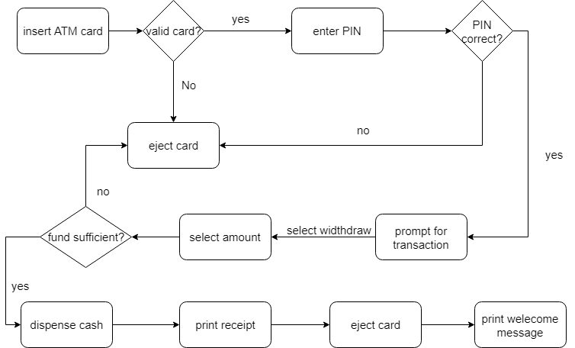

**Test case:** customer has 1000 yuan in the account and he got to the ATM to with draw 100 yuan.

**Use case 2**

**Use Case Name**: Transfer Funds

**Summary**: Customer uses a valid card to transfer funds from a valid bank account to another valid bank account

**Actor**: ATM Customer

**Precondition**: ATM is displaying the idle welcome message

**Description**:

1. Customer inserts an ATM Card into the ATM Card Reader.

2. If the system can recognize the card, it reads the card number.

3. System prompts the customer for a PIN.

4. Customer enters PIN.

5. System checks the expiration date and whether the card has been stolen or lost.

6. If card is valid, the system checks whether the PIN entered matches the card PIN.

7. If the PINs match, the system finds out what accounts the card can access.

8. System displays customer accounts and prompts the customer to choose a

type of transaction. Three types of transactions are Withdraw Funds, Get Balance, and Transfer Funds. (The previous eight steps are part of all three use cases; the following steps are unique to the Withdraw Funds use case.)

9. Customer selects Transfer Funds, selects account number, and enters the amount and enter the aim account number.

10. System checks that the account is valid, makes sure that the customer has enough funds in the account, makes sure that the daily limit has not been exceeded, and checks that the aim account is valid.

11. If all checks are successful, the system transfer the cash.

12. System prints a receipt with a transaction number, the transaction type, the amount withdrawn, and the new account balance.

13. System ejects card.

14. System displays the idle welcome message.

**Activity diagram:**

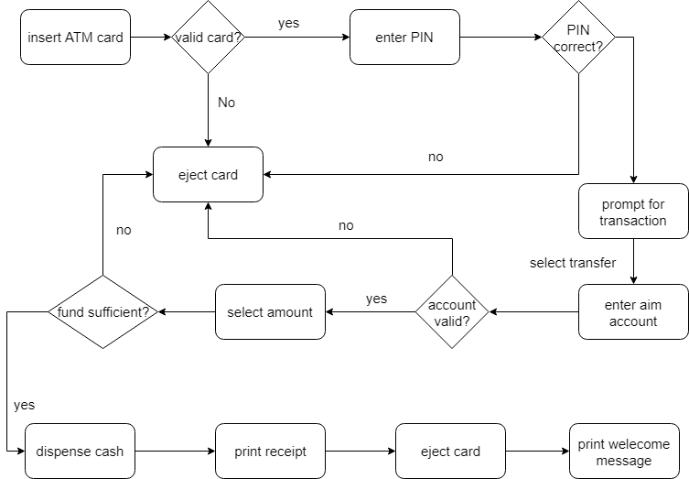

**Test case:** the customer go to ATM and enter correct account information and select transfer fund and enter correct aim account number and enter the reasonable amount of money(suppose have 1000 in account and transfer 100) and finish transfer.